|  |
| --- |
|  |

|  |
| --- |
| **Chefridge** |
| Interactive Systems Design Coursework |
|  |
| Coursework for the module ISD in the Pg/Msc ACSD. Goal: “to design an innovative handheld device or smart product for your own use.” |
|  |
| **Mario A. Corchero Jiménez B00228364** |
| **08/12/2011** |
|  |

# Content

Content 1

Introduction 2

Product Specification 3

Potential users’: 3

Potential users’ function requirements: 3

Potential users’ usability criteria: 4

Conclusions of the surveys 4

Similar devices 5

In my fridge 5

Smart Fridgerator 6

Electrolux External Refrigerator 7

Bio Robot Refrigerator 8

Initial designs 9

Designs Evaluation 10

References 11

# Introduction

This coursework, titled Chefridge, seeks the design of a smart fridge for Interactive System Design, one module of a PgD/MSc in Advanced Computer System Development. The document is divided in 5 parts:

* Specification: Think about the interactive product you are designing and look for requirements for the device or product, together with some usability criteria making some surveys to potential users (3-5).
* Similar devices: Look around for similar devices or products and seek out other sources of inspiration that you might find helpful. Make a note of any findings that are interesting, useful or insightful.
* Initial designs: Sketch out some initial designs for the device. Try to develop two distinct alternatives that both meet your set of requirements.
* Designs evaluation: Evaluate the two designs, using your usability criteria and by role playing an interaction with your sketches. Involve potential users in the evaluation, if possible.

# Product Specification

## Potential users’:

### Melania Cano:

Job: Student.  
Age: 22 years  
Gender: Female.

### Sheila Love:

Job: Teacher, Retired.  
Age: 64 years.  
Gender: Female.

### Fidela Jimenez:

Job: Housekeeper.  
Age: 58 years.  
Gender: Female.

### Olga Corchero:

Job: Philosophy teacher.  
Age: 40 years.  
Gender: Female

## Potential users’ function requirements:

### Melania Cano:

* To be noticed when the food is going to expire.
* To automatically recommend recipes with available food in the fridge.
* To guide in the cooking process, by voice or highlighting a semi-transparent screen.
* To provide diets, even insert a weight to loose and follow the diet process.
* To provide easy controls (like a button only) get juices or water without opening the fridge.

### Sheila Love:

* To slice, dice and peel the vegetables.
* To juice the fruit to make a drink.
* To make a recipe of the day depending on what’s in the fridge.

### Fidela Jiménez:

* Different areas to regulate the temperature separately.
* To be noticed when food is going to expire.
* To programme a food to be defreeze at a specific time/date.
* To provide fast cold water and ice without opening the fridge.

### Olga Corchero:

* Control the stock of the food inside the fridge and notice when some food should be rebought.
* Advice about the nutrients already eaten and the food that should be eaten to reach the diary recommendations when you are close to the fridge.

## Potential users’ usability criteria:

### Melania Cano:

* The doors should be tow transparent touchable screens.
* Lights to report the expired food.

### Sheila Love:

* Play music and say welcome when the fridge is opened.
* To be a polite fridge.
* Use a touch screen to show the recipes and other functions.
* Change colour depending on the seasons.

### Fidela Jimenez:

* Two doors to open the fridge
* Buttons to get outside the ice and the water.
* Different touch-Screen in the fridge to set temperatures and defreeze programs for every area.
* Turn on a red light when some food is going to expire in a specific area.

### Olga Corchero:

* Transparent touch screen over the entire fridge door.
* Voice about the nutrition recommendations when get close to the fridge.
* Red cross for the food that should not be eaten and green circle for the recommendable one having in mid the nutritional advices.

## Conclusions of the surveys

The product to design is a smart fridge that provides water/ice/juice without having to open it, provides some ways to help the customer in the cook providing diets and recipes with the food contained inside it, automatically emit an advice when some food is going to expire and it’s going to incorporate different sections with different temperatures.

The main idea is to combine a personal electronic chef/nutritionist with a refrigerator.

# Similar devices

## In my fridge

This design by Fabian Kreuzer and Markus Lorenz Schilling, October 2011, is close to be the design we are looking for.

It’s provided with a Semi-transparent touchscreen as the primary interface that allow to see the food inside the fridge and perform some activities like ask the cheapest place to buy the items that are going to deplete.

The door is the touchscreen itself and it is shifted to the right instead of opened.

Using “Radio-Frequency Identification” controls the stock inside the fridge.



### Notes

The idea about having a transparent touchscreen is really useful and user-friendly, all surveyed users said they want it as the primary interface.

The worst of the design, the way to open the door, every fridge nowadays is opened pulling, so the users will try to open it this way and will be hard for them to get used to this fridge way of opening. In addition, it doesn’t let to control the “speed of opening” really well and limits the fridge position so it could not be sited next to a wall.

## Smart Fridgerator

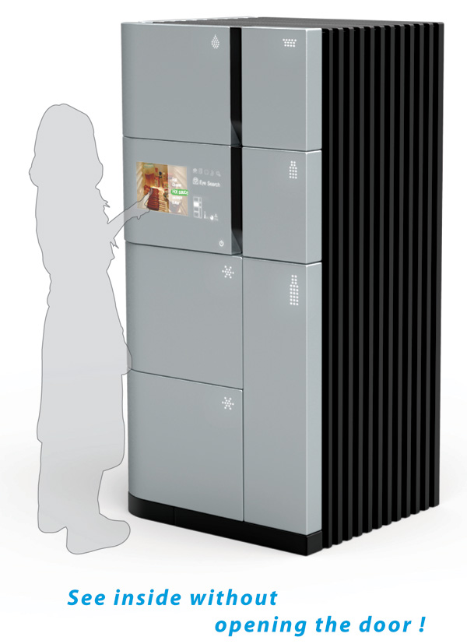Designed by Jeong-hun Yang & Gyeong-chan Han, September 2011, the design promises to be more energy safe.

This fridge provides different sections to localize faster the food, also with two cameras in each section, it controls every object that you get out or put into the fridge. The main objective is save energy, so when you want something, you can check the section where it’s placed with a touchscreen in the centre of the fridge.

The list of food that the fridge contains is transmitted to the phone.

This design supposed to save lot of energy because you open only the section you need when an item is needed.

### Notes

Divide in sections to separate the items is a good idea, but have some important problems bounded, the user may feel confused if he don’t know where to place a food exactly or maybe some sections get collapsed whilst other remains almost empty. Those problems could be solved if the sections are not already identified and could be user-customized.

Another problem with the usability is the way to find the items, it’s slower to use the touchscreen and tell to it the item you are looking for than open each door. Moreover, to start using the screen it’s needed to push a button power, slowing more the process to find an item. Probably, if the sections were semi-transparent, will be easier to find each item.

## Electrolux External Refrigerator

This model of fridge, by Nicolas Hubert in September 2010, has something unique, doesn’t take space inside the home.

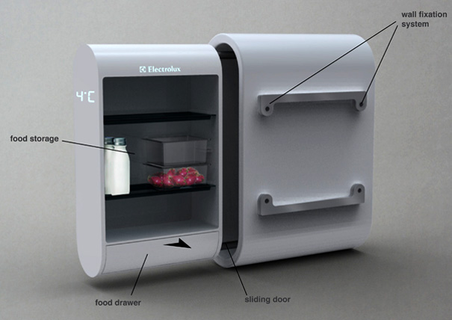The fridge is sited outside the home, and the door is opened giving it a push to get the food through the window. The fridge shows the temperature and a control to change the temperature in the “door” (the side to be pushed).

### Notes

This fridge supposes a saving in space in the kitchen, but has some problems with the usability.

* Sometimes hard to open the door.
* The buttons are wrong sited, when you open the door you might push some button accidentally.
* In the most of cases, the windows are set up before buying the fridge, and probably the window has not the dimensions recommended for the window, making more difficult to get some food and just interact in general with the fridge.
* The buttons (in touch-screen) don’t seems to be buttons, it may be confused for the customer.

## Bio Robot Refrigerator

Yuriy Dmitriev shows a completely different design of fridge. The fridge presents a different way to interact with him. The fridge has no door and it’s made from biopolymer gel letting you to drop or take the items directly in the fridge, the gel is odourless and not sticky. The fried can be placed horizontal, vertical or even in the celling. Also, there are some small buttons on the sides of the fridge for other capabilities.

### Notes

The way to interact with the fridge to pick or drop food it’s really easy when there are few items, but when the fridge becomes really populated, it start to be difficult to find the item you are looking for.

Moreover, some users don find disgusting to touch the gel to drop or pick the items, and the fridge is not well designed if you want to refrigerate a really big bottle of water.

Finally we need reject the colour of the gel, green, so it’s not adequate to store food for the most of the people.

# Initial designs

# Designs Evaluation

# References

* Fabian Kreuzer and Markus Lorenz Schilling, October 2011, “In my fridge”  
  <http://vimeo.com/29675966>
* Jeong-hun Yang & Gyeong-chan Han, September 2011, “Smart fridge”   
  <http://www.yankodesign.com/2011/10/11/fridge-that-knows-it-all/>
* Nicolas Hubert, September 2010, “External Refrigerator”  
  <http://www.electroluxdesignlab.com/2010/08/electrolux-design-lab-2010-finalist-nicolas-hubert/>
* Yuriy Dmitriev, October 2010, “Bio Robot Refrigerator”  
  <http://www.electroluxdesignlab.com/2010/08/electrolux-design-lab-2010-finalist-yuriy-dmitriev/>